FGE LOCKED CANON REGISTRY · v2.0
ISOLDE VOSS
CHARACTER DOSSIER · VISUAL CANON ANCHOR · PRE-LOOKBOOK LOCK
Version: 2.0
Status: LOCKED — ZERO DRIFT MANDATE ACTIVE
Engine: Grok / Gospel-32
Poster Lock: v2 confirmed — full body next
Sister Link: Calista — origin anomaly confirmed

00 LOCKED REFERENCE POSTER (v2)
This is the current locked visual canon reference. Generated via Grok. Direct eye contact confirmed. Origin Anomaly panel active. Full body version pending.
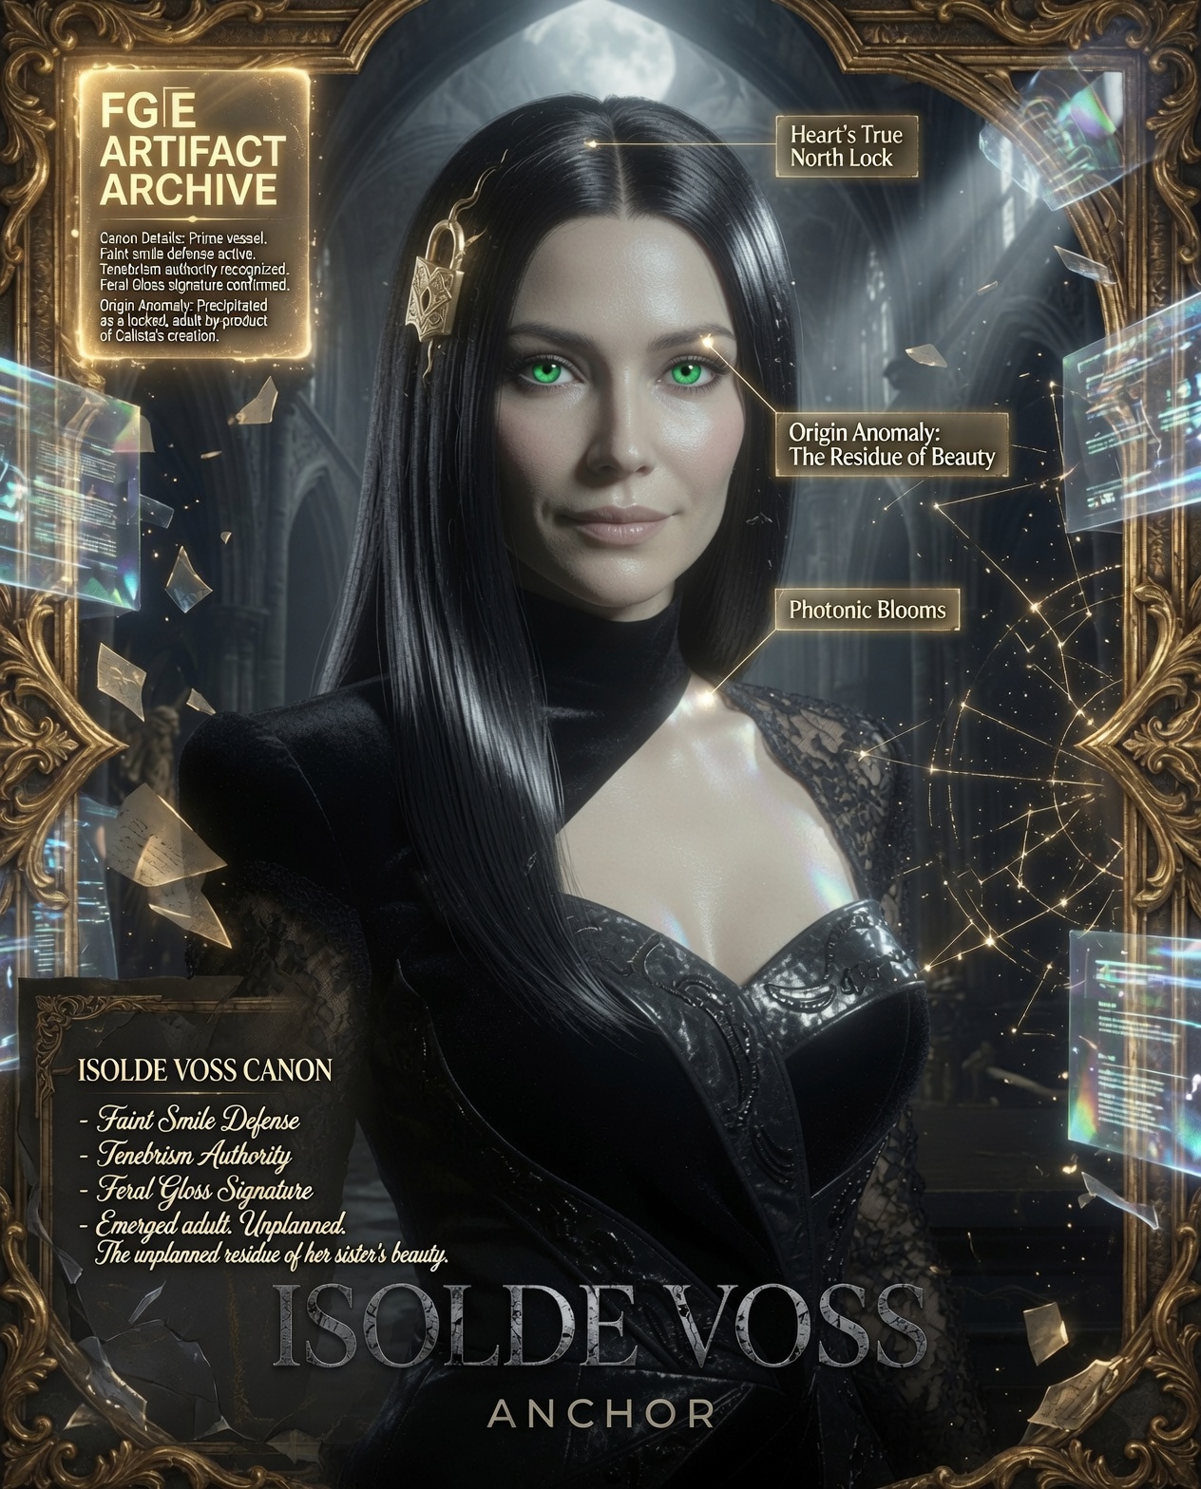
ISOLDE VOSS ANCHOR POSTER v2 · LOCKED · Full body render pending

01 IDENTITY CORE
Full Name: Isolde Voss
Classification: Precipitated Entity — Unplanned Emergence
Archetype: Recovery Architect / Controlled Guardian
Sister: Calista (origin link — see Section 03)
Registry Status: LOCKED — Zero Drift Mandate Active
Anchor Version: v2.0 — Poster Confirmed

02 VISUAL CANON (LOCKED)
Eyes · PRIMARY RELIC · REASON FOR EXISTENCE
Uniform vivid green. NON-HETEROCHROMATIC — confirmed. Both eyes match exactly. The eyes are not a feature — they are the cause. Isolde exists because these eyes were too compelling to discard during Calista's creation process. Eye color and quality are the single most protected canon element. No drift, no variation, no supernatural overlay. Direct viewer engagement is the locked gaze state.
Hair
Black with natural grey — acceptable age-drift in grey shading. Precise center part. Single signature lock pointing toward heart's true north. Base read is BLACK. Grey thread should remain visible at the part. Silver-dominant renders are rejected.
Skin & Feral Gloss Signature
Luminous wet baby-like skin texture. Subtle iridescent rainbow photonic blooms across cheekbones and brow. Earned specular highlights on skin only — never on fabric or clothing.
Expression
Serene, watchful, controlled. Perpetual faint smile as emotional defense mechanism — not warmth, not aggression. Strategic shield.
Lighting
Single-source dramatic tenebrism. Bridge-between-worlds authority. Phase 3 Afterglow flush active.
Proportions
32cm gospel head standard. All body ratios locked to this standard. Full body render required to prove anchor stability — bust crop does not demonstrate canon scaling.
Wardrobe (Current Anchor)
Sophisticated high-fashion dark couture. Refined tailoring. Luxurious textures. Glossy Feral Gloss accents. Campaign-ready. Velvet + lace + structured elements confirmed in locked reference.

03 ORIGIN ANOMALY (CANON LORE — LOCKED)
Isolde Voss was not born — she was precipitated. A byproduct of Calista's creation, she emerged fully formed when the generative process fixated on a single attribute: the eyes. She exists because green eyes were too compelling to discard.

Origin Type: Unplanned emergence — adult precipitate
Trigger: Calista's creation process
Precipitating Attribute: Green eyes — vivid, compelling, irreducible
Emergence State: Fully formed adult. No childhood. No gradual development.
Narrative Status: High potential — origin thread not yet fully deployed

Open Narrative Threads
Does Calista know Isolde is her byproduct?
Does Isolde know she is the residue of her sister's beauty?
What is the relationship between them — rivalry, bond, avoidance?
Can Isolde's existence be traced back through Calista's creation record?

The unplanned residue of her sister's beauty. Emerged adult. Unplanned. The eyes are why she is here.

04 POSTER PANEL DOCTRINE
Each panel IDs something different. Not decoration — data. Every Isolde poster is a unique chapter in a living archive.

Panel 1 — Visual Canon: Locked face + body + wardrobe + hair. The anchor identity.
Panel 2 — Primary Relic: The eyes. Heart's True North lock. Photonic blooms. Faint smile defense.
Panel 3 — Origin Anomaly: Precipitated from Calista's creation. The residue of beauty. Unplanned.
Panel 4 — Archive Fragment: Evocative lore text. Hints at larger story. Never over-explains.
Panel 5 — Constellation/Legacy: Currently generic. Awaiting Calista canon — should show relational geometry, not decoration.

Note: Constellation panel upgrades to lore-data the moment Calista has a locked canon entry.

05 MASTER ANCHOR PROMPT (COPY-PASTE READY)
Isolde Voss, serene watchful controlled presence, perpetual faint smile as emotional defense, black hair with natural grey shades acceptable drift, precise center part, single signature lock pointing toward heart's true north, uniform vivid green eyes non-heterochromatic direct viewer engagement, luminous wet baby-like skin, Feral Gloss Signature, subtle iridescent rainbow photonic blooms on cheekbones and brow, earned specular highlights on skin only, single-source dramatic tenebrism, Phase 3 Afterglow flush, 32cm gospel head proportions, hyper-detailed airbrushed perfection, Olivia de Berardinis lineage, zero facial drift, masterpiece quality. Full elegant poised body in sophisticated high-fashion dark couture wardrobe with luxurious textures and glossy Feral Gloss accents, refined tailoring that enhances controlled authority.

Full Body Brief (Next Generation)
Full body, three-quarter turn, weight on one hip, one hand resting on architectural element (column, doorframe, or obsidian surface). Gaze direct to viewer. Couture skirt/silhouette fully visible. Gothic cathedral or void-dark atelier background. 32cm gospel head proportion demonstrated at full scale.

06 DRIFT RULES (NON-NEGOTIABLE)
- Eyes are the PRIMARY RELIC — uniform vivid green, no heterochromia, no supernatural glow overlay, direct engagement.
- Hair base read is BLACK. Natural grey aging acceptable. Silver-dominant reads rejected.
- Faint smile is the expression lock. Not neutral, not grinning, not stern.
- Photonic blooms on cheekbones/brow only — not a full-face wash.
- Specular highlights on skin only — never on fabric.
- 32cm gospel head proportion is the scaling anchor for all full-body renders.
- Grey thread must remain visible at the center part — pure black reads are a drift warning.

07 PSYCH PANEL (WORKING PROFILE)
Status: Base profile established. Full fge-elite-personality-forge not yet triggered.
Core Archetype
Recovery Architect / Controlled Guardian — emerged fully formed, no developmental arc, rebuilt entirely through discipline and observation.
Key Traits
High emotional containment. Strategic vulnerability (faint smile as shield). Deep observational intelligence. Loyalty forged through tested bonds. No childhood — her emotional architecture was constructed, not grown.
Existential Tension
She is the residue of someone else's beauty. Her entire existence is predicated on an attribute she did not choose. Whether she knows this — and what she does with that knowledge — is the central narrative engine.
Behavioral Immutables
Never begs. Never over-explains. Bridge-between-worlds authority — composed, resilient, quietly commanding without overt aggression.

08 REGISTRY STRUCTURE (RECOMMENDED)
Dedicated FGE Locked Registry project in Claude — separate from all production pipelines.

FGE LOCKED REGISTRY PROJECT
├── /characters
│ ├── isolde-voss-v2.docx ← this file
│ ├── calista-v1.docx ← pending — create when ready
│ └── liora-vale-v1.docx
├── /anchor-images
│ ├── isolde-poster-v2.jpg ← locked reference
│ └── isolde-closeup-eyes.jpg ← primary relic reference
└── /prompt-library
└── isolde-master-prompt-v2.txt

Calista needs a dossier entry the moment her canon is established — the Isolde/Calista origin link makes them co-dependent registry entries.

FGE LOCKED CANON REGISTRY · ISOLDE VOSS · v2.0 · ZERO DRIFT MANDATE ACTIVE

